**Design System:**

1. **Learn what a design system is (components, styles, spacing, icons).**

A design system is a collection of reusable design elements, components, and guidelines that ensure consistency across a product or brand. It acts as a single source of truth for designers and developers, streamlining the design process and maintaining a cohesive look and feel.

**Key Elements of a Design System:**

* **Components**
* Reusable UI elements (e.g., buttons) with consistent properties.

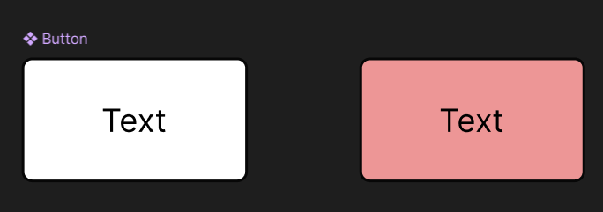

* The “Text” on the right is a child component.
* Help maintain consistency and reduce repetitive work.
* **Styles**
* **Color Styles** (Primary, Secondary, Backgrounds, Text)
* **Text Styles** (Heading 1, Heading 2, Body, Caption)
* **Effects** (Shadows, Blurs)

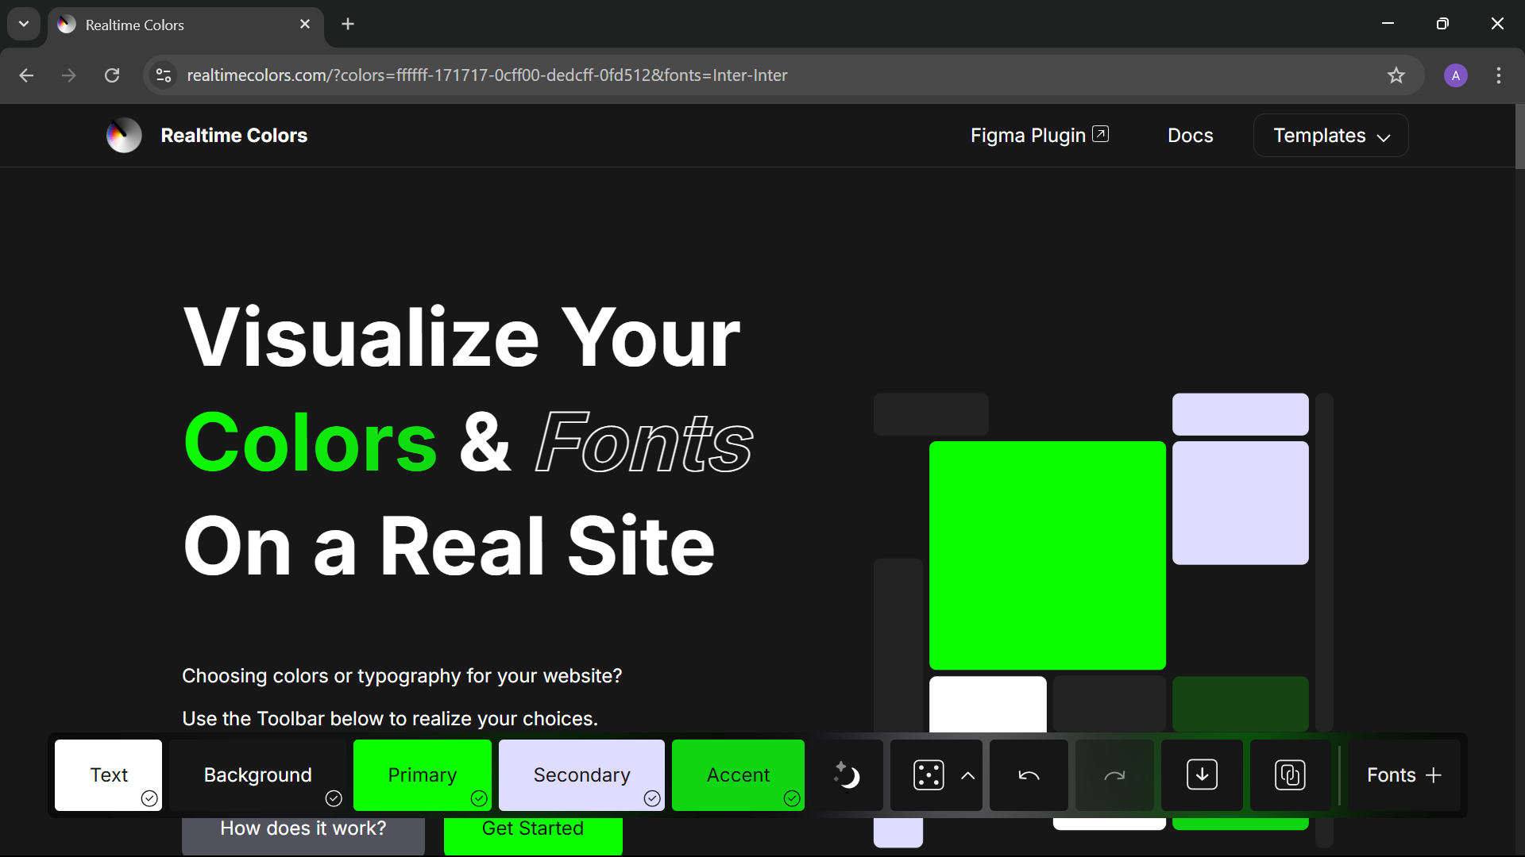

* **Grid and Layouts**

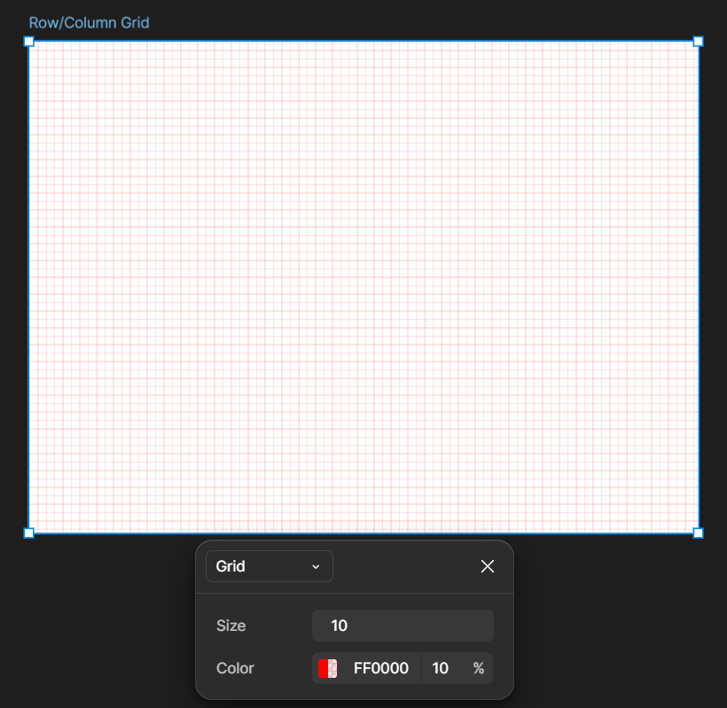

* **Spacing**
* Use a spacing scale (e.g., 4px, 8px, 16px, 32px) to define padding, margins, and gaps.

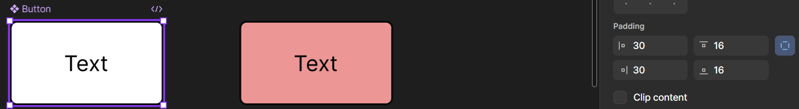

* Ensures consistency across layouts.
* **Icons**
* Use consistent icon styles (line, solid, filled).
* Organize icons into sets and make them components for easy reuse.

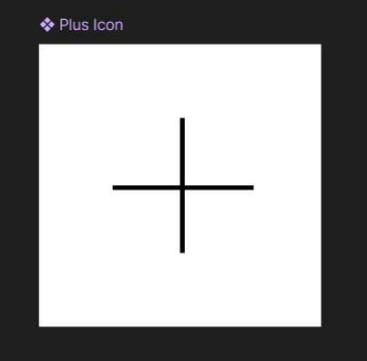

1. **Create reusable components: buttons, forms, nav bars, cards.**

**Creating a Button Component:**

**Steps:**

* **Add Text**
  + Label it e.g., “Primary Button”.
  + Apply your **Text Style** (e.g., any size, Black color).



* **Apply Auto Layout**
  + Press “shift” and “A” to add auto layout to the text.

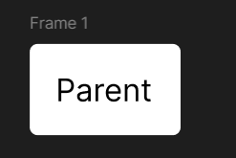

* **Component**
* Click on the frame then at the top right side there will be an option called component just beside the dev.
* Click on the component and thus you have made a component button.

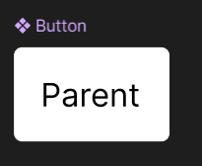

* You can also access it through the assets bar on your left. But it will be a child component and any changes in the parent will affect the child, but at the other side any changes in the child will not affect parent.

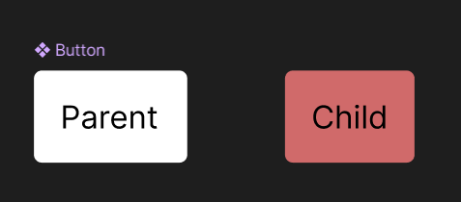

**Form Input Component:**

We will create a simple login/sign up page which will focus on taking inputs from the user.

**Step 1:**

Create a frame then add “Login” and “sign up” buttons to it.

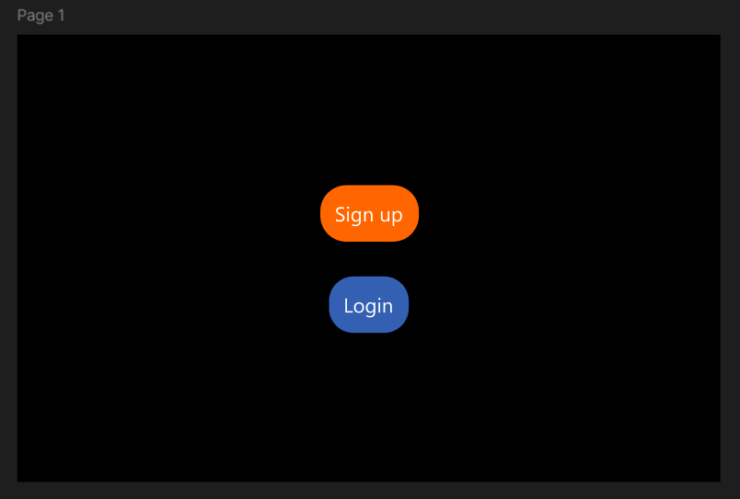

**Step 2:**

Similarly create another frame and add the following.

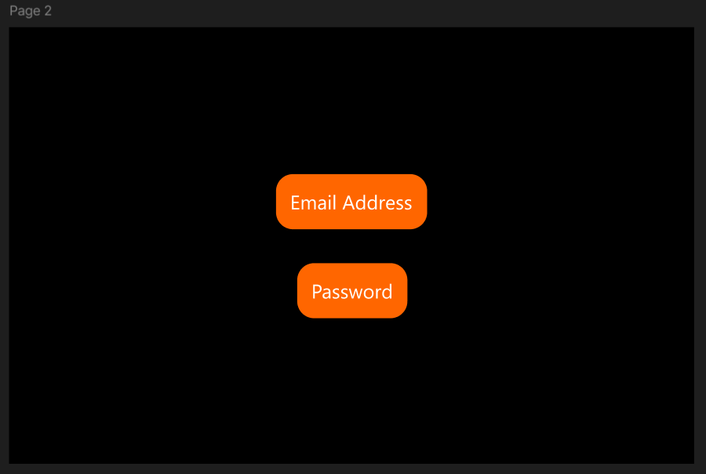 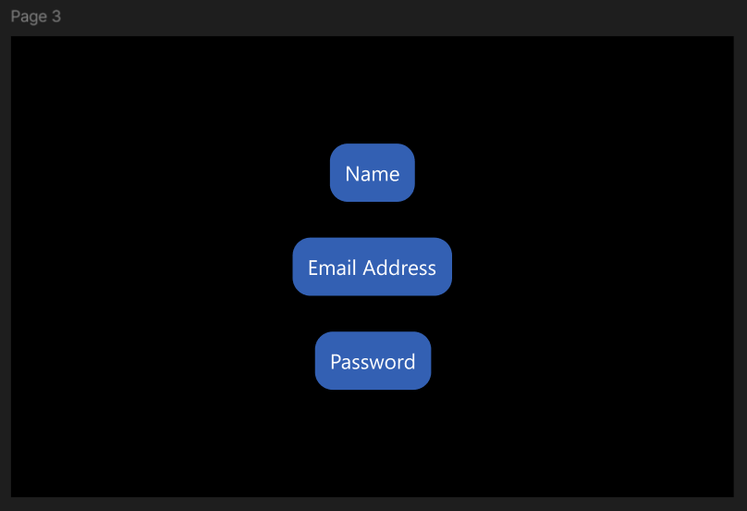

**Step 3:**

Now just add Prototype and for animation click on the top right button.

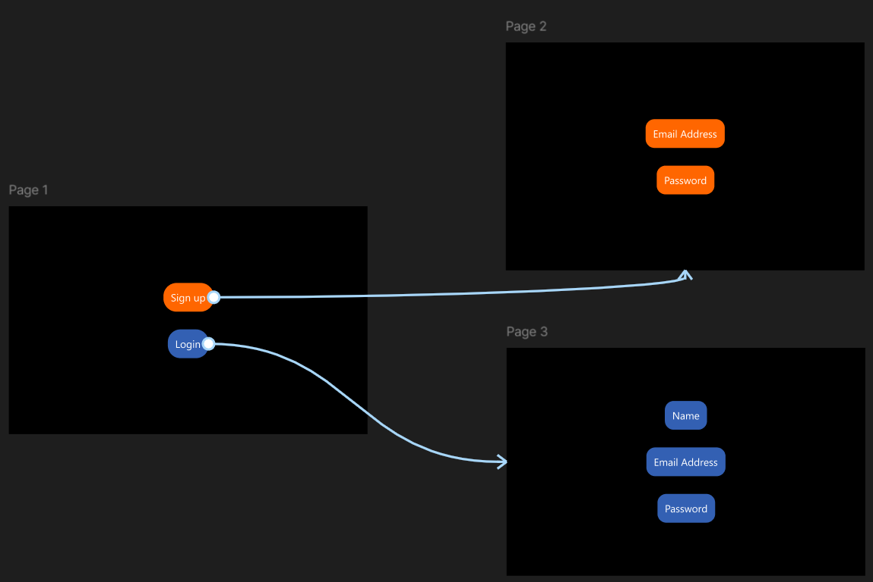

**Navigation Bar:**

In this Spotify clone project, the **bottom navigation bar** serves as the primary means for users to navigate between core sections of the application. Though non-functional in this prototype, it visually replicates the experience and layout of the official Spotify mobile app’s bottom nav.

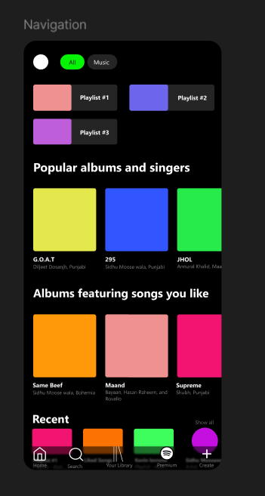

### ****Purpose of Bottom Navigation****

The bottom navigation bar is designed to:

* Provide quick and easy access to **key features**
* Enhance **usability** by keeping controls within thumb reach
* Maintain a clean, **mobile-friendly layout**

### ****Tabs Included in the Bottom Bar****

1. **Home** – Represents the main screen where users typically land. It would show suggested playlists, trending songs, etc.
2. **Search** – Lets users discover artists, songs, albums, or genres. Positioned centrally for quick access.
3. **Library** – Allows users to browse their saved music, playlists, and liked songs.
4. **Premium** – A CTA (Call-to-Action) tab promoting Spotify Premium with upgrade options.

**Card Component:**

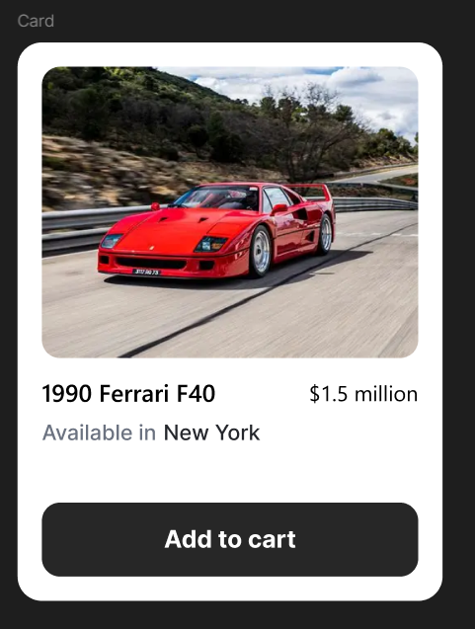

This card component is a **clean, modular UI element** designed to present a luxury product — the **Ferrari F40** — in a visually appealing and user-friendly way. The card combines image, product details, and a call-to-action to simulate a real e-commerce product card.

**Purpose of the Card**

* To **showcase a product** (Ferrari F40) in a simple and elegant format
* To **provide important information at a glance** — name, image, price
* To allow user action with an **"Add to Cart" button** (even if non-functional)

**Card Structure Breakdown**

1. **Car Image**
   * A large, eye-catching image placed at the top.
   * Visually communicates the product and grabs attention.
2. **Car Name (Title)**
   * Displays "Ferrari F40" clearly.
   * Uses bold, premium-looking font to reflect the luxury brand.
3. **Price**
   * Clearly shows the cost of the car (e.g., **$1,600,000**).
   * Styled to be noticeable and trustworthy.
4. **Add to Cart Button**
   * Gives the impression of interactivity and purchase option.
   * Uses a consistent button component from the design system.
   * Even if it’s not functional, it completes the shopping-card look.

**3. Organize components in Figma using Auto Layout and Variants.**

* **Auto Layout**

Auto Layout helps you:

* Keep spacing between elements equal
* Automatically adjust the size when content changes
* Align items easily (top, center, left, etc.)

Before Auto Layout:

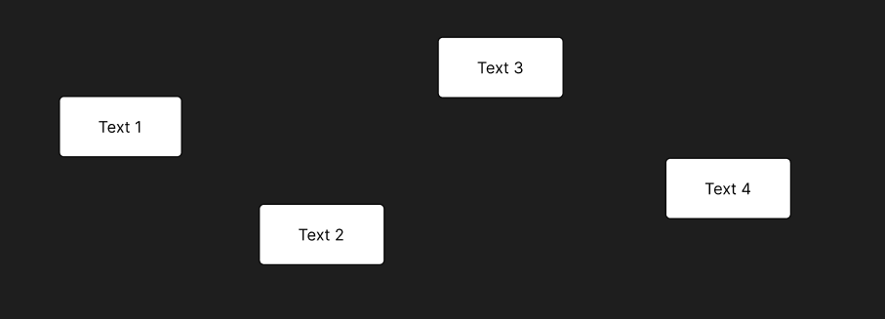

After Auto Layout:

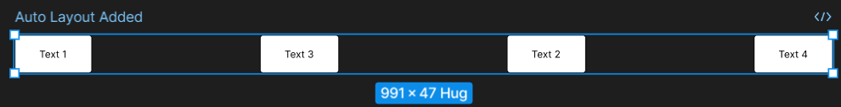

Example: If you make a button with text inside, Auto Layout will keep the text centered and add padding around it.

* **Variants**

Variants let you create different **versions** of the same component inside one main component.

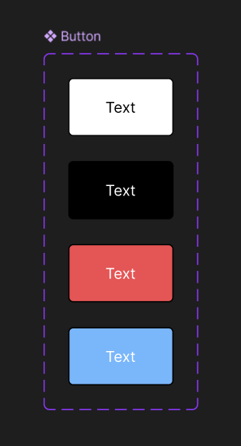

Example: A button can have;

* Default
* Hover
* Disabled  
  All in one place as "variants" instead of making 3 separate components.

**Usability Testing:**

Usability testing is basically observing how users interact with a design to find out what works well and what’s confusing. It can be done in person or remotely, depending on what's easier. In my case, I kept things simple and focused on remote unmoderated testing — meaning I just gave users a Figma prototype and asked them to try some tasks.

1. **Learn how to conduct usability tests (in-person or remote).**

#### **Goal:**

Find out if users can use your design easily, what confuses them, and how to improve it.

#### **What is Usability Testing?**

It’s a method where you **watch real users** try your design to see:

* Where they get stuck.
* What they expect to happen.
* What’s working well.

**Types of Usability Testing:**

|  |  |  |
| --- | --- | --- |
| **Type** | **How It Works** | **When to Use** |
| In-Person | You sit with the user and observe. | Small, focused tests. |
| Remote | You send a link and collect feedback. | When users are far away. |
| Moderated | You guide the user during the session. | For deep understanding. |
| Unmoderated | User tests on their own (recorded or form). | Fast and scalable. |

### ****Steps to Prepare for a Usability Test****

I created short tasks that users could perform using my prototypes. For example:

* In the Spotify clone, I asked them to explore the bottom nav bar and try to “go to the Library” or “find the Premium page.”
* For the Ferrari F40 card, the task was to look at the product and try to “understand what it offers” — basically seeing if the user understood the price, image, and Add to Cart action right away.

The idea was to simulate how a user would react if they saw this UI in a real app.

**Tools I Used to Collect Feedback**

To collect feedback easily, I used **Google Forms** and shared the prototype links from Figma.

* I asked simple questions like:
  + “Was anything confusing?”
  + “What part caught your attention first?”
  + “Did you feel like you knew what to do next?”

I kept the form short to avoid overwhelming users, especially since the tests were quick and focused.

1. **Use Tools Like Maze, Lookback, or Google Forms**

**Option 1: Maze**

* Connect your **Figma prototype** to Maze.
* Set up **tasks** and **questions** in Maze (like “Click the button to play music”).
* Share the link with testers.

**How to Use:**

* Go to [maze.co](https://maze.co)
* Create a project ---> Import from Figma
* Define tasks and success conditions
* Share test link
* Get results (clicks, paths, time, etc.)

**Option 2: Google Forms**

If you want a simple feedback tool:

1. Create a form with questions like:
   * What was confusing?
   * What did you like?
   * Was it easy to use?
2. Add a link to your Figma prototype in the form.
3. Send to users.

**Option 3: Lookback**

Great for **recorded** usability testing:

* Allows video + screen + voice.
* Better for deep feedback.

**Steps:**

1. Go to [lookback.io](https://lookback.io).
2. Set up a study.
3. Invite users.
4. Watch recordings afterward.
5. **Analyze Results and Iterate on Designs**

* **Collect Results**
  + From Maze: check task success, misclicks, heatmaps
  + From Forms: read answers
  + From Lookback: watch recordings and note where users struggled
* **Highlight Key Issues**
  + Make a list of what confused users or caused delay
  + Example:
    - “User didn’t see the play button”
    - “User thought the ‘Buy’ button would show more info”
* **Decide What to Fix**
  + Pick **high-priority** problems that affect most users
  + Use insights to **improve UI**
* **Iterate Your Design**
  + Go back to Figma
  + Update your screens or flow
  + Make buttons more visible, fix layout, add instructions
* **Re-test (optional)**
  + Once updated, repeat usability testing to see if it's improved

### Making Small Iterations in Figma:

After reviewing the feedback, I made small changes directly in Figma:

* For the **Spotify UI**, I adjusted icon spacing and added simple text labels below each tab.
* For the **Ferrari card**, I made the price slightly bolder and moved it closer to the “Add to Cart” button to make the grouping clearer.

Even though these designs weren’t functional, the small UI tweaks made them feel more polished and easier to understand.

**Summary/Conclusion:**

|  |  |  |
| --- | --- | --- |
| **Steps** | **What to do** | **Tools** |
| **1** | Learn how usability testing works. | Watch tutorials, UX blogs. |
| **2** | Choose task, create scenario, prepare prototype. | Figma. |
| **3** | Run test using Maze, Lookback, or Google Forms. | Maze, Lookback, Google Forms. |
| **4** | Analyze what worked or failed. | Review feedback & heatmaps. |
| **5** | Improve your design based on feedback. | Figma (Iteration). |

**UX Writing & Microcopy:**

**Understand the importance of microcopy (tooltips, button text, errors)**

**UX writing** is all about writing the small bits of text that users interact with in a digital interface. This includes:

* Button labels
* Tooltips
* Error messages
* Placeholder text
* Empty states
* Confirmation texts

These small texts are called **microcopy**, and although they’re short, they make a **huge impact** on how users feel while using your design.

**Step 1:** Understanding the Importance of Microcopy

**Why Microcopy Matters**

* Helps guide users through the UI
* Reduces confusion
* Adds personality and brand tone
* Makes the interface feel more human

Imagine opening an app that just says "Submit" and "Error" everywhere. You wouldn’t know what’s going on, right?

Now compare that with buttons like "Play Now" or messages like "Oops! Something went wrong. Try again." That feels clearer and friendlier.

**Example** “Spotify Clone”

**Without UX Writing:**

* Button text: “Go”
* Tooltip: None
* Error: “Error”

**With Good UX Writing:**

* Button: **“Start Listening”**
* Tooltip on Search: **“Find songs, artists, or playlists”**
* Error: **“We couldn’t load your playlist. Please try again.”**

These small tweaks **guide the user** and match the tone of a music app — friendly, light, and fast.

**Example** “Ferrari F40 Card"

**Without UX Writing:**

* Button text: “Buy”
* Price: Just a number
* No tooltip or guidance

**With Good UX Writing:**

* Button: **“Add to Cart”**
* Tooltip: **“Click to add this car to your collection”**
* Label near price: **“Starting at”** $1,600,000

These changes give the card **more context** and make it feel like a luxury e-commerce experience, not just a static layout.

**Write clear and concise UI text to guide users**

**Spotify Clone – Microcopy Examples:**

|  |  |  |
| --- | --- | --- |
| **Elements** | **UX Text used** | **Examples** |
| Bottom nav labels | Home, Search, Library, Premium | Simple and self-explanatory |
| Search bar placeholder | “Search for artists, tracks, or albums” | Helps users know what they can type |
| Error message (for non-functional search) | “This feature is coming soon” | Friendly way to show it's just a mockup |
| Empty state. | “Your library is empty – let’s fill it with music!” | Adds personality, keeps user engaged |

**Ferrari F40 Card – Microcopy Examples:**

|  |  |  |
| --- | --- | --- |
| Elements | UX Text used | Examples |
| Car title | “Ferrari F40 – 1987 Classic Icon” | Adds emotional value to the title |
| Price label | “From $1,600,000” | Sounds more elegant and market-like |
| Add to Cart button | “Add to Cart” | Standard action wording users expect |
| Tooltip (hover on price or car image) | “This is a visual mockup – pricing is not real” | Helps avoid confusion |

UX Writing is not just about text — it's about **helping users** move through your interface smoothly, with confidence.  
In both my designs (Spotify clone and Ferrari card), I added **microcopy that fits the mood of the product**:

* In Spotify, the tone was **fun, friendly, and fast**.
* In the Ferrari card, it was **premium, simple, and clear**.

Even though these projects are not functional, adding the right microcopy made them feel **polished and realistic** — like real apps people could use.